The Title of the Paper: Submission _.
This is the subtitle of the paper, this document both explains and embodies the submission format for authors using Word
FIRST AUTHOR'S NAME, INITIALS, AND LAST NAME
First author's affiliation, an Institution with a very long name
SECOND AUTHOR'S NAME, INITIALS, AND LAST NAME
Second author's affiliation, possibly the same institution
THIRD AUTHOR'S NAME, INITIALS, AND LAST NAME
Third author's affiliation, possibly the same institution
Although there is no distinctive header, this is the abstract.
Keywords and Phrases: Insert comma delimited author-supplied keyword list, Keyword number 2, Keyword number 3, Keyword number 4
- Introduction
- Inserting Content Elements
The next subsections provide instructions on how to insert figures, tables, and equations in your document.
  - Tables
Tables are “float elements” which should be inserted after their first text reference and have specific styles for identification. Do not use images to present tables, or they will be inaccessible to readers using assistive technologies.
Authors can insert tables by using the MS Word option (INSERT ->Table) and providing the required row and column size. Every table must have a caption (title) above it, which must have the “TableCaption” style applied. Please note that tables should not be supplied as image files, but if they are images they must have the “Image” style applied. As an example, Table 1 shows all the styles available in this template, to be applied to the respective element of your text.
Table 1: Styles available in the Word template
Style Tag | Definition | Style Tag | Definition
Title_document | main title of article | ListParagraph | list items
Subtitle | subtitle of article | Statements | math statements
Authors | author name | Extract | block quotations
Affiliation | author affiliation information | Algorithm Caption | caption for algorithm
AuthNotes | footnote to author(s) | AckHead | heading for acknowledgements
Abstract | abstract text | AckPara | acknowledgements text
CCSHead | heading for CSS Concepts | GrantSponsor | sponsor of grant
CCSDescription | CSS terms | GrantNumber | number for the grant
KeyWordHead | heading for keywords | ReferenceHead | heading for references
Keywords | keywords text | Bib_entry | references
ORCID | author's ORCHID # | AppendixH1 | appendix heading level 1
Head1 | heading level 1 | AppendixH2 | appendix heading level 2
Head2 | heading level 2 | AppendixH3 | appendix heading level 3
Head3 | heading level 3 | TableCaption | title of table
PostHeadPara | first paragraph after a heading | TableHead  TableFootnote | column head of table  footnote to table
Para | Subsequent paragraphs of general text | Image | figures
ParaContinue  DisplayFormula | flush left text after display items like math equations, lists etc.  numbered math equation | DOI | Digital object identifier
DisplayFormulaUnnum | unnumbered equations | Label | label
Tables can be very difficult for people using screen reader technology to understand unless they include markup that explicitly defines the relationships between all the parts (i.e.: headers and data cells). A key to making data tables accessible to screen reader users is to clearly identify column and row headers. In Word, authors should identify which row or rows contain column headers. Below are the steps to do this:
- Select that table’s row, then right-click the row and select “Table Properties”;
- In the Table Properties window, click the Row tab and select the box that says “Repeat as header row at the top of each page.”
  - Figures
Figures are “float elements” which should be inserted after their first text reference, and have specific styles for identification. Insert a figure and apply the “Image” paragraph style to it. For the figure caption, apply the style “FigureCaption.”
To accommodate readers with color vision differences, figures should still be usable when printed in grayscale. Refer to elements of the figure with non-color terms, for example “indicated as squares” instead of “indicated in blue”. Use different patterns in bar charts, different line patterns in graphs, and different shapes in plots to distinguish groups of elements and reinforce color differences.
    - Half Width Figures.
Figure 1 is an example of a figure and caption spanning the half-page width (one column in a two column format) with the styles applied. If your figure contains third-party material, you must clearly identify it as such, as shown in the example below.
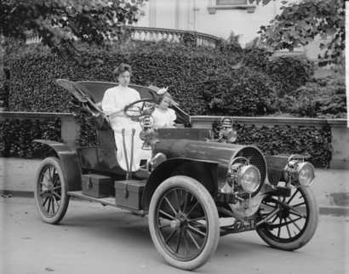
Figure 1: 1907 Franklin Model D roadster. Photograph by Harris & Ewing, Inc. [Public domain], via Wikimedia Commons. (https://goo.gl/VLCRBB)
    - Full Width Figures.
Figure 2 is an example of a figure and caption spanning the full-page width with the styles applied. If your figure contains third-party material, you must clearly identify it as such, as shown in the examples.
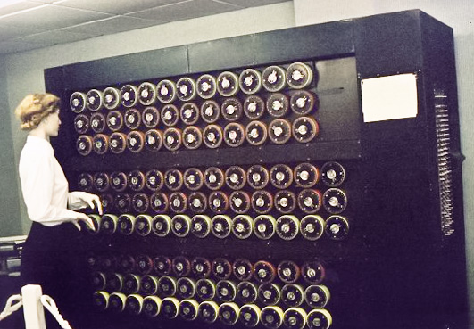
Figure 2: Mockup of a bombe machine at Bletchley Part. Photograph by Sarah Hartwell. [Public domain], via Wikimedia Commons. (https://commons.wikimedia.org/wiki/File:TuringBombeBletchleyPark.jpg)
    - Figure Descriptions.
Every figure should have a figure description unless it is purely decorative. These descriptions convey what’s in the image to someone who cannot see it. They are also used by search engine crawlers for indexing images, and when images cannot be loaded.
A figure description must be unformatted plain text less than xxx characters long. Figure descriptions should not repeat the figure caption – their purpose is to capture important information that is not already provided in the caption or the main text of the paper. For figures that convey important and complex new information, a short plain text description may not be adequate. More complex alternative descriptions can be placed in an appendix and referenced in a short figure description. For example, provide a data table capturing the information in a bar chart, or a structured list representing a graph. For additional information regarding how best to write figure descriptions and why doing this is so important.
The instructions below describe the required steps authors need to follow in order to insert descriptive text for figures (alt-txt value) in MS Word 2019 on Windows or Word 2016 and later on Mac:
- Insert a picture in the document.
- Right-click the image and select “Edit Alt Text”.
- Citing Related Work
This section cites a variety of journal [5, 15], conference [1, 6, 8, 12, 13], and magazine [3] articles to illustrate how they appear in the references section. It also cites books [9, 10], a technical report [7], a PhD dissertation [4], an online reference [14], a software artifact [11], and a dataset [2].
As you build your article, you should note where you will be placing citations. If you are using numbered citations and references, the reference number - "...as shown in [5]..." is sufficient. If you are using the "author year" style, a reasonable placeholder is the primary author's last name and the year of publication - "...as shown in [Harel 1978]..." - we will be updating this placeholder later in the process with the citation label as generated by the Word macros in the "master template."

ACKNOWLEDGMENTS
Acknowledgments are placed before the references. Add information about grants, awards, or other types of funding that you have received to support your research. Author can capture the grant sponsor information, by selecting the grant sponsor text and apply style ‘GrantSponsor’. After this, select grant no and apply ‘GrantNumber’ from style panel. Example of Grant sponsor: Competitive Research Programme and example of Grant no: CRP 10-2012-03.
REFERENCES
- Atul Adya, Paramvir Bahl, Jitendra Padhye, Alec Wolman, and Lidong Zhou. 2004. A multi-radio unification protocol for IEEE 802.11 wireless networks. In Proceedings of the IEEE 1st International Conference on Broadnets Networks (BroadNets’04) . IEEE, Los Alamitos, CA, 210–217. https://doi.org/10.1109/BROADNETS.2004.8
- Sam Anzaroot and Andrew McCallum. 2013. UMass Citation Field Extraction Dataset. Retrieved May 27, 2019 from http://www.iesl.cs.umass.edu/data/data-umasscitationfield
- Martin A. Fischler and Robert C. Bolles. 1981. Random sample consensus: a paradigm for model fitting with applications to image analysis and automated cartography. Commun. ACM 24, 6 (June 1981), 381–395. https://doi.org/10.1145/358669.358692
- Chelsea Finn. 2018. Learning to Learn with Gradients. PhD Thesis, EECS Department, University of Berkeley.
- Jon M. Kleinberg. 1999. Authoritative sources in a hyperlinked environment. J. ACM 46, 5 (September 1999), 604–632. https://doi.org/10.1145/324133.324140
- Matthew Van Gundy, Davide Balzarotti, and Giovanni Vigna. 2007. Catch me, if you can: Evading network signatures with web-based polymorphic worms. In Proceedings of the first USENIX workshop on Offensive Technologies (WOOT ’07) . USENIX Association, Berkley, CA, Article 7, 9 pages.
- James W. Demmel, Yozo Hida, William Kahan, Xiaoye S. Li, Soni Mukherjee, and Jason Riedy. 2005. Error Bounds from Extra Precise Iterative Refinement. Technical Report No. UCB/CSD-04-1344. University of California, Berkeley.
- David Harel. 1979. First-Order Dynamic Logic. Lecture Notes in Computer Science, Vol. 68. Springer-Verlag, New York, NY. https://doi.org/10.1007/3-540-09237-4
- Jason Jerald. 2015. The VR Book: Human-Centered Design for Virtual Reality. Association for Computing Machinery and Morgan & Claypool.
- Prokop, Emily. 2018. The Story Behind. Mango Publishing Group. Florida, USA.
- R Core Team. 2019. R: A Language and Environment for Statistical Computing. R Foundation for Statistical Computing, Vienna, Austria. https://www.R-project.org/
- Brian K. Reid. 1980. A high-level approach to computer document formatting. In Proceedings of the 7th Annual Symposium on Principles of Programming Languages. ACM, New York, 24–31. https://doi.org/10.1145/567446.567449
- John R. Smith and Shih-Fu Chang. 1997. VisualSEEk: a fully automated content-based image query system. In Proceedings of the fourth ACM international conference on Multimedia (MULTIMEDIA ’96). Association for Computing Machinery, New York, NY, USA, 87–98. https://doi.org/10.1145/244130.244151
- TUG 2017. Institutional members of the LaTeX Users Group. Retrieved May 27, 2017 from http://wwtug.org/instmem.html
- Alper Yilmaz, Omar Javed, and Mubarak Shah. 2006. Object tracking: A survey. ACM Comput. Surv. 38, 4 (December 2006), 13–es. https://doi.org/10.1145/1177352.1177355

